HALVES, THIRDS AND QUARTERS
KS1 – 2003 Paper 2
1.
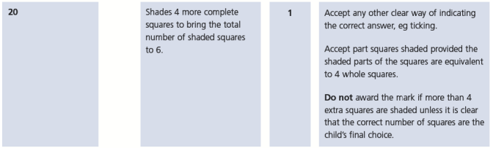
KS1 – 2004 Paper 1
2.
KS1 – 2004 Paper 2
3.
KS1 – 2005 Paper 2
4.
3/4

KS1 – 2007 Paper 2
5.
KS1 – 2009 Paper 2
6.
KS1 – 2016 Paper - Arithmetic
7.
8.
9.
10.
KS1 – 2016 Paper - Reasoning
11.
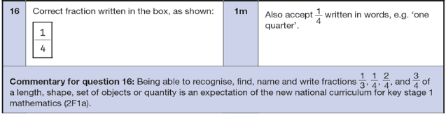
KS1 – 2016 Paper - Arithmetic (Second)
12.
13.
14.
15.
KS1 – 2017 Paper – Arithmetic
16.

17.
KS1 – 2018 Paper – Arithmetic
18.
19.
KS1 – 2019 Paper – Arithmetic
20.
21.
22.
KS1 – 2019 Paper – Reasoning
23.
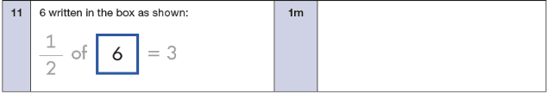
24.
KS1 – 2022 Paper – Arithmetic
25.

26.
KS1 – 2022 Paper – Reasoning
27.
